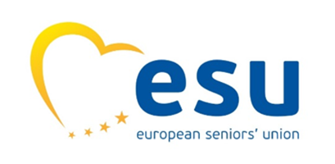
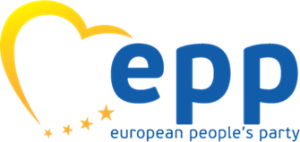



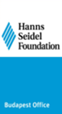


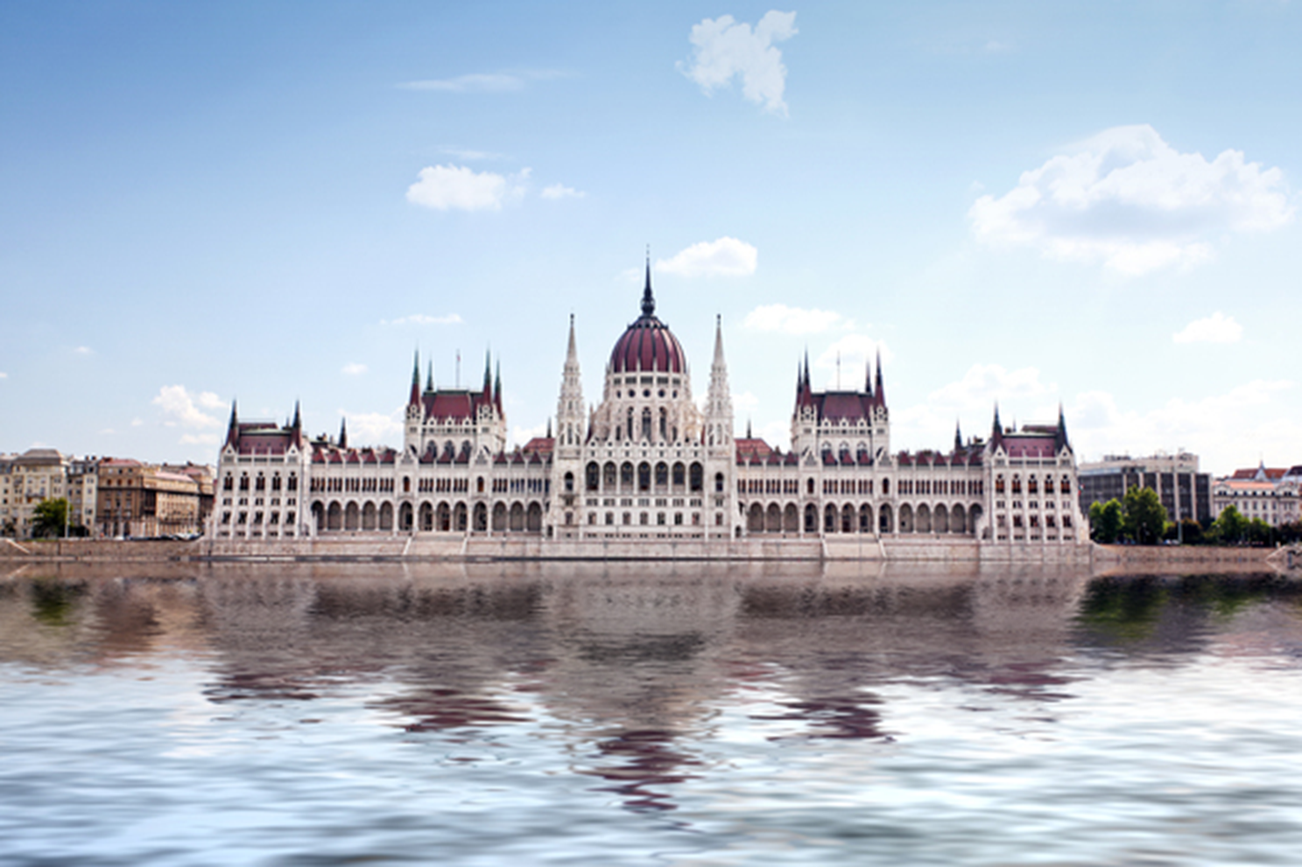
Bridging Generations: Solidarity, Policy, and Innovation in a Changing Europe
Budapest Spring Conference on Intergenerational Dialogue and Solidarity, 28 – 30 April 2026
Conference Report

The publication of this document received financial support from the European Parliament. Sole liability rests with the author. The European Parliament is not responsible for any use that may be made of the information contained therein.

Foreword by Manfred Weber, President of the EPP

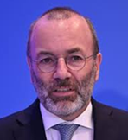

Solidarity among generations is a cornerstone for our society and for the EPP. A society where all ages - young citizens, parents, families and older citizens – can thrive. Too often, public debate frames generations as competitors. This is wrong: it weakens the social contract at the basis of our European Union. A continent that puts generations against each other cannot remain united, competitive and politically stable.

Intergenerational solidarity means recognising a simple truth: Europe’s future depends on bringing generations together fairly. This requires clear priorities, including fair and sustainable welfare systems, investment in people across the entire life course, recognising gender equality as a necessary condition of our society and a strong support for SMEs as engines of employment, innovation and intergenerational exchange.

As the strongest political family in Europe, the EPP has the duty to improve intergenerational solidarity in Europe, by focusing on these priorities and designing policies that are fair, economically sound and future‑proof. The contribution of EPP Associations through joint initiatives, such as the Budapest Spring Conference on Intergenerational Dialogue and Solidarity, is essential. This cooperation carries strong political weight, as it enables the representation of a broad community that brings together continuity and change, experience and ambition, as well as economic progress and social responsibility.

Progress cannot be achieved in silos. It requires a coordinated approach, strong collaboration, and a shared vision. The EPP stands ready to make it happen.

------------------------------------

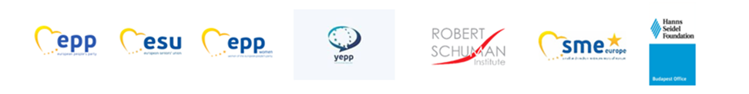

Report

Introduction
The conference brought together policymakers, experts, and representatives of civil society to examine the evolving relationship between generations in Europe. Against the backdrop of demographic change, digital transformation, and shifting labour markets, discussions focused on strengthening intergenerational solidarity, ensuring fairness in public policy, and leveraging the combined strengths of different age groups for social and economic resilience.

Panel 1: Bridging the Generational Divide – Challenges and Opportunities
The opening panel explored how demographic shifts, migration, digitalisation, and changing labour markets are reshaping intergenerational relations. Speakers emphasized that generational divides are not inevitable but must be actively addressed through dialogue, inclusion, and policy innovation.
A key message was that intergenerational solidarity is not automatic; it requires deliberate investment in participation, communication, and institutional frameworks. Younger generations show strong willingness to engage, provided they are treated as equal partners with real decision-making power. At the same time, older generations remain an underutilised resource, contributing valuable experience, stability, and social capital.
A distinction was made between active retirement and advanced old age, highlighting the importance of recognising pensioners as active contributors to society. Initiatives such as pensioners’ associations and intergenerational community projects were presented as effective tools for engagement and inclusion.
The panel also underlined that intergenerational dialogue is essential for social cohesion and democratic legitimacy. Evidence from across Europe shows that shared decision-making increases trust in institutions, civic participation, and solidarity. Conversely, lack of interaction reinforces stereotypes and social fragmentation.
Key priorities identified included:
- Rebuilding trust among younger generations
- Supporting informal care systems without overburdening families
- Expanding structured opportunities for intergenerational cooperation

Workshops Round 1

1. Policy Approaches to Promote Intergenerational Fairness
This workshop examined how public policies can balance the needs of different generations while ensuring long-term sustainability.
A central argument was that intergenerational solidarity must move from principle to practice, becoming an integral part of governance. Despite growing awareness, there is still a lack of mechanisms to systematically assess the long-term impact of policies on future generations.
Participants stressed that effective policy design requires:
- Age-inclusive labour markets
- Adequate and sustainable pension systems
- Strong long-term care frameworks
- Investment in lifelong learning and digital inclusion
The discussion also highlighted the role of Artificial Intelligence (AI). While AI offers opportunities to enhance independence, healthcare, and participation for older persons, it also risks deepening inequalities if access and usability are not addressed. Inclusive design, digital education, and human-rights-based safeguards were identified as essential.
A broader conclusion was that intergenerational fairness depends on coherent, comprehensive policy frameworks, rather than isolated measures.

2. Social Protection & Care — Sustainable, Fair Systems
This workshop focused on adapting welfare systems to demographic ageing while maintaining fairness and social rights.
A rights-based perspective emphasized that social protection systems must be evaluated not only for financial sustainability, but also for:
- Adequacy
- Accessibility
- Coverage
- Responsiveness to different life stages
Intergenerational solidarity was framed as both a distributional and structural issue—not only how resources are shared, but also how care responsibilities are organised within society.
Key debates included:
- The balance between rights and responsibilities across generations
- Gender inequalities in pensions and care systems
- Ethical questions around healthcare allocation
- The growing political influence of older populations versus weaker youth representation

Participants stressed that connectiveness, dialogue, and subsidiarity are essential for maintaining social cohesion. Solidarity cannot rely solely on institutional frameworks; it must also be rooted in active civic engagement.
A notable point was the need to rethink the post-retirement phase, recognising the potential of healthy older individuals to contribute through voluntary or even structured social engagement.

3. Generations in Business: Experience, Innovation, and Competitiveness
This workshop explored how intergenerational collaboration can strengthen European businesses.
Speakers highlighted that:
- Older professionals contribute experience, strategic thinking, and stability
- Younger generations bring innovation, digital skills, and adaptability
When combined effectively, these strengths drive growth, innovation, and competitiveness.
A major theme was the skills gap in a rapidly evolving labour market, driven by technological change and AI. Addressing this challenge requires:
- Lifelong learning and reskilling systems
- Education aligned with future labour market needs
- Inclusive workplace cultures that value all age groups
Technology was presented as both an opportunity and a risk. While it can transform sectors like healthcare and entrepreneurship, it may also lead to social disconnection if not guided by ethical considerations.
Entrepreneurship emerged as a key area for intergenerational cooperation. Recommendations included:
- Improving access to funding and mentorship
- Facilitating business succession
- Reducing administrative burdens
- Supporting student-led initiatives and practical learning models
Student organisations and junior enterprises were highlighted as effective bridges between education and the business world, fostering early entrepreneurial experience and cross-generational collaboration.

Part II
Workshops Round 2 & Panel 2: Building Inclusive, Digital, and Participatory Societies Across Generations
The second part of the conference focused on practical pathways to strengthen intergenerational cooperation through lifelong learning, digital inclusion, civic engagement, and real-world best practices. Discussions emphasized that demographic change and technological transformation require not only policy adaptation, but also a cultural shift toward shared responsibility, participation, and continuous learning.

Workshop Round 2

1. Lifelong Learning & Employment — Active Ageing and Youth Opportunities
This workshop addressed how education systems and labour markets must evolve to remain inclusive, competitive, and resilient in the face of demographic and economic pressures.
A central message was that Europe is undergoing simultaneous structural changes: increasing life expectancy, shrinking youth cohorts, and intensifying global competition. These shifts challenge traditional life models and require a rethinking of how societies approach work and learning.
Participants stressed that the linear life model—education, work, retirement—is no longer viable. Instead, individuals must be able to:
- Continuously update their skills
- Transition between roles across their lifetime
- Remain active contributors to society at all ages
Knowledge was identified as Europe’s key strategic asset. However, the challenge lies in better sharing and applying knowledge across generations, particularly through mentoring, reskilling, and intergenerational collaboration.
The discussion also highlighted that employment is not only economic, but also social. Work provides:
- Purpose and dignity
- Social belonging
- Opportunities for participation
A recurring concern was intergenerational inequality:
- Young people often feel disadvantaged compared to previous generations
- Older individuals face barriers to remaining active in the workforce
The conclusion was clear: investment in people, fairness, and social cohesion is as important as investment in technology.

2. Digital Inclusion & Access — Bridging the Digital Divide
This workshop explored how to ensure equal access to digital tools, skills, and services across all age groups.
A key focus was the transformative role of Artificial Intelligence (AI). Rather than viewing AI solely as disruptive, speakers emphasized its potential to:
- Simplify technology use
- Improve access to services
- Support lifelong learning
- Foster inclusion, particularly for older generations
The discussion called for a human-centered approach to digitalisation, where technology strengthens social cohesion instead of deepening divides.
However, significant challenges remain:
- Only a minority of older people acquire digital skills despite available training
- Lack of follow-up after training limits long-term impact
- Unequal access to devices and connectivity persists
One proposed solution was the systematic organisation of intergenerational volunteering, where younger people support older individuals in developing digital skills. This approach combines skill-building with social connection.
Another important theme was access to reliable information. Being well-informed was described as a fundamental right and a source of empowerment, particularly in democratic societies.
The concept of a “knowledge cascade” was introduced as a model to connect research, policy, and community-level action. Intergenerational cooperation was seen as essential to making digital transformation more inclusive and equitable.

3. Civic Engagement & European Identity — Toward a New Democratic Pact
This workshop examined how stronger civic participation across generations can reinforce democracy and a shared European identity.
A key concern raised was the erosion of collective identity in modern societies. Increasing individualism and social fragmentation risk weakening democratic participation and creating vulnerabilities that can be exploited by populist or authoritarian forces.
Speakers argued that:
- Democracy depends not only on institutions, but on active, engaged citizens
- Human rights must be lived and practiced, not only formally recognised
- A renewed sense of collective purpose (“the we”) is essential
Intergenerational cooperation was identified as a powerful tool to rebuild this shared identity. By working together, younger and older generations can:
- Counter stereotypes and exclusion
- Strengthen mutual understanding
- Enhance democratic resilience

The workshop also addressed labour market challenges affecting youth, including insecurity and limited opportunities, which can undermine trust in institutions and participation in public life.
At the same time, older generations were encouraged to remain actively engaged. A strong message emerged that seniors continue to have agency and responsibility in shaping society.
Key conclusions included:
- Civic engagement must be supported at all stages—from awareness to leadership
- Reliable information is essential for democracy
- Simplistic political solutions must be resisted in favour of active participation
- Solidarity across generations is fundamental to democratic stability

Panel 2: Best Practices & Experiences from Member Organisations
The final panel showcased concrete initiatives and lessons learned from organisations across Europe, highlighting how intergenerational cooperation can be implemented in practice.
A key theme was the importance of moving beyond zero-sum narratives between generations. Instead of framing demographic change as a burden, speakers presented it as an opportunity to build more inclusive and cohesive societies.

Key Examples and Insights
- Intergenerational Policy Dialogue:
Civil society organisations demonstrated how involving older people directly in policy discussions can strengthen legitimacy and promote balanced solutions. Active participation helps ensure that policies reflect real-life experiences across generations.
- Inclusive Education and Social Awareness:
Projects focusing on education highlighted the need to address stigma, particularly around disability and health conditions. Creating safe environments for sharing experiences fosters empathy and inclusion across age groups.
- Cultural Engagement through Art:
Cultural initiatives, such as intergenerational festivals, were presented as powerful tools for breaking down barriers. Art enables communication beyond language and age, creating shared experiences that reduce prejudice and strengthen community bonds.
- Community-Based Approaches:
Successful practices emphasized the role of local engagement, where intergenerational interaction becomes part of everyday life rather than isolated initiatives.

Across all examples, a common principle emerged: intergenerational dialogue is most effective when it is practical, continuous, and rooted in real community experiences.

Key Cross-Cutting Themes
Across all sessions, several overarching insights emerged:

1. Intergenerational Solidarity as a Shared Responsibility
Solidarity must involve both rights and responsibilities. It requires mutual recognition, fairness, and active participation from all age groups.

2. The Importance of Dialogue
Regular, meaningful interaction between generations is essential to reduce stereotypes, build trust, and strengthen democratic systems.

3. Policy Integration and Long-Term Thinking
Intergenerational fairness must be embedded across policy areas, including fiscal policy, social protection, digitalisation, and climate action.

4. The Role of Technology
Digitalisation and AI offer transformative potential but risk exacerbating inequalities without inclusive design and access.

5. Demographic Change as a Structural Challenge
Ageing populations and declining fertility rates require a rethinking of welfare systems, labour markets, and societal roles.

Several overarching lessons emerged from the second part of the conference:

1. Lifelong Learning as a challenge for all.
Continuous education is essential to adapt to economic and technological change and to ensure participation across all ages.

2. Digital Inclusion as a Social Priority
Bridging the digital divide requires not only infrastructure, but also human-centered design, education, and intergenerational support.

3. Civic Engagement as the Foundation of Democracy
Active participation from both youth and seniors is crucial to maintaining democratic resilience and a shared European identity.

4. Intergenerational Cooperation in Practice
Real-world examples show that collaboration across generations strengthens social cohesion, reduces inequalities, and fosters innovation.

Conclusion
The conference underscored that Europe’s future depends on its ability to bridge generational divides through cooperation, fairness, and innovation. Intergenerational solidarity is not merely a social ideal but a practical necessity for sustainable development, democratic stability, and economic resilience.
Building inclusive societies will require:
- Stronger policy frameworks
- Investment in participation and dialogue
- Recognition of the contributions of all generations
Ultimately, the discussions pointed toward a shared goal: a Europe where generations do not compete, but collaborate to shape a common future.
The second part of the conference reinforced a central message: Europe’s future depends on its ability to connect generations through learning, participation, and shared responsibility.
Lifelong learning, inclusive digital transformation, and active civic engagement are not separate challenges - they are interconnected pillars of a resilient society. By combining policy innovation with practical initiatives, Europe can transform demographic change into an opportunity for renewal, ensuring that all generations contribute to - and benefit from - a common future.

-------------------------------------------------------

A participant’s evaluation of the Conference

« The organisation was excellent and we especially appreciated the inclusion of small, guided working groups as well as the usual plenary sessions.
In addition to the extensive range of voices and experiences, it was especially interesting to hear from younger people and local students there. Also, that you had invited other groups (Active Retirement Ireland, AGE Platform Europe and UNESCO) added very positively to the experience.
The contributions regarding the increasing role of AI, with its positive and negative aspects, were also very stimulating.”

-------------------------------------------------

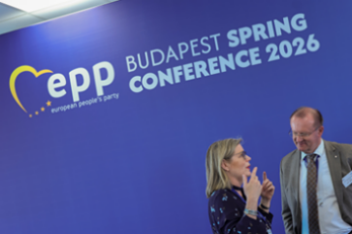
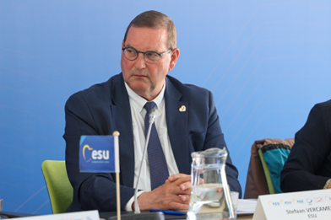
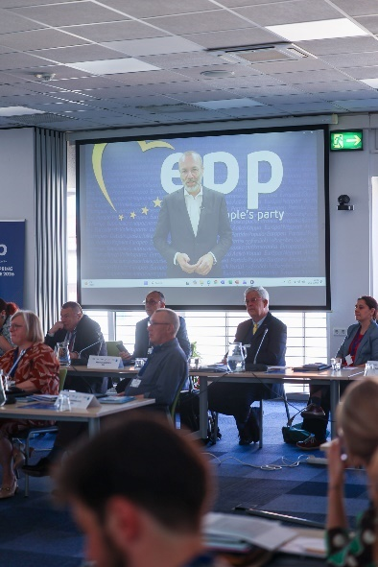
The Conference Photo Gallery

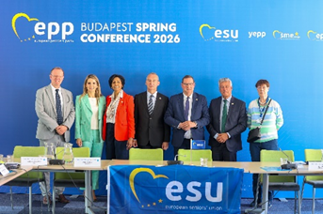

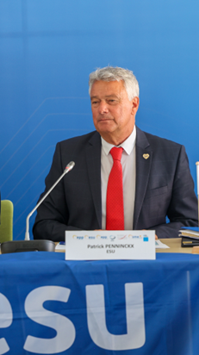

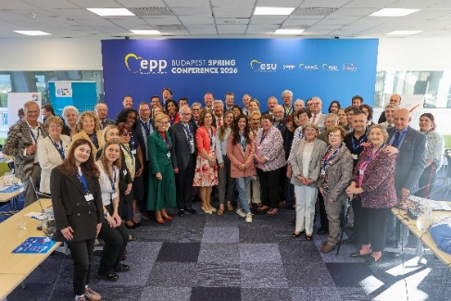
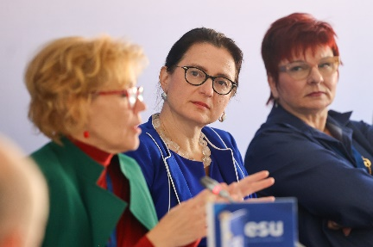

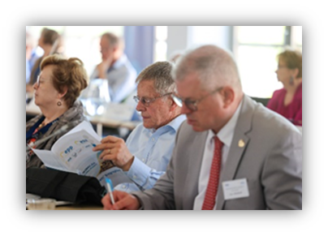
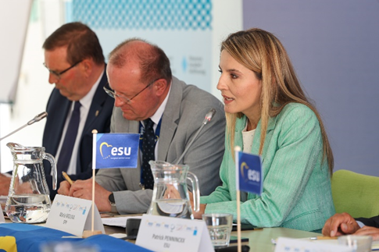

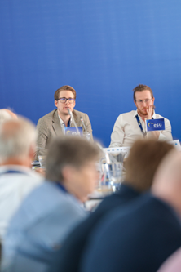

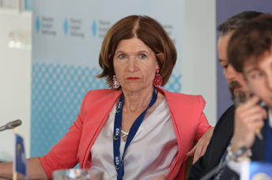


Appendix: the Conference Programme

Tuesday, 28 April 2026 | 19:00 Welcome dinner and informal networking  - Balint Molnar, Executive Director, EYCB  - Stefaan Vercamer, President, ESU  - Rozalia Biro, Vice-President, EPP Women
Wednesday, 29 April 2026 | 09:30 Opening Session  Introduction and presentation of Guest Speakers, Programme and the “EU Day of Solidarity between Generations”  Overall Conference Moderator and General Rapporteur: Patrick Penninckx, Secretary General, ESU  “The Importance of Intergenerational Solidarity in Contemporary Europe” — setting the tone and rationale”  Keynote Speaker: video-message from Manfred Weber, President of the EPP  “Why a UN Convention on the Rights of Older Persons”  Keynote Speaker: Claudia Mahler, Independent Expert on the enjoyment of all human rights by older persons  “Two weeks after the elections in Hungary, conclusions and perspectives”  Keynote Speaker: Daniel Molnar, TISZA Youth, YEPP  Welcome by Dr Markus Ehm, Head of Hans Seidel Foundation Budapest  10:15 Panel 1: Bridging the Generational Divide: Challenges and Opportunities  Explore generational gaps: demographic change, labour market, digitalisation, social cohesion, identity, migration, inclusion, ageism (younger and older generations - challenges, misunderstandings, and expectations)  Keynote Speaker: Dr Gudrun Kugler, ÖVP, MP in Austria  Panel Members:  - Rozalia Biro, Vice-President, EPP Women  - Jan Vanhee, Senior Advisor on Youth  - Tobias Drilling, Advisory Council on Youth, Council of Europe  Moderator: Kalliopi Marangaki, Vice-President, ESU  11:30 Coffee/Tea Break
11:45 Workshops Round 1:
  - Policy Approaches to Promote Intergenerational Fairness
Discuss concrete policies: pensions, social protection, long-term care, health, digital inclusion, lifelong learning, employment — how to ensure fairness across generations. The different lived experiences of the generations across regions of Europe
Keynote: Dr. Peter Hefele, Policy Director, Wilfried Martens Center
Panel members:
- Gábor Berczeli, Director, Robert Schuman Institute
- Philippe Seidel Leroy, Policy Manager on Social and Economic Policies / European Parliament Liaison, AGE Platform Europe
- Andrea Eder-Gitschthaler, Vice President, ESU
- Tobias Drilling, Advisory Council on Youth, Council of Europe
Moderator/Rapporteur: Danilo Bussi, YEPP

  - Social Protection & Care — sustainable, fair systems
Keynote: Tatiana Puiu– Vice-President European Committee of the Social Charter, Council of Europe
Panel members:
- Cor Spreeuwenberg, Vice-President, ESU
- Ria Oomen-Ruijten, former Treasurer, EPP Women
Moderator / Rapporteur: Chiara Gullotta, Educational Advisor, EYCB

  - Generations in Business: How Europe turns Experience into Growth and Youth into Innovation and Competitiveness
Keynote: Dr. Nadine Lilienthal, Head of Legal Expertise & Alliance DACH of Dili Trust, CEO & Founder of legaleap.law, Business Angel Raketenstart, SMEC Ambassador for AI
Panel Members:
- Daria-Patricia Dolea, Business Organization for Students Romania, Junior Enterprises Europe
- Michael Jäger, President of the Taxpayers Association of Europe
- Louis Delcart, Member of the Board of Directors, The European Academy of the Regions
Moderator / Rapporteur: Horst Heitz, Secretary General, SME Europe

13:00 Lunch Break

14:30 Workshops Round 2:
- Lifelong Learning & Employment — keeping seniors active + opportunities for youth - competitiveness
Keynote: Dr. Peter Hefele, Policy Director, Wilfried Martens Center
Panel members:
- Sari Rautio, President of EPP Group, Committee of the Regions
- Dr. Gabriele Peus-Bispinck, Vice-President, ESU
Moderator / Rapporteur: Jannes Herman Mostert, Robert Schuman Institute

- Digital Inclusion & Access — bridging the digital divide
Keynote: Milton Garcia, AI Consultant / Managing Partner
Panel members:
- Peter Mach, Vice-President, ESU
- Mojca Škrinjar, Vice-President, ESU
- Yulia Cherdantseva, Associate Project Officer, UNESCO
Moderator / Rapporteur: Alessandro D’Onofrio, Robert Schuman Institute

- Civic Engagement & European Identity — youth and seniors participating together for a New Democratic Pact with capacity building for the full cycle of political participation and leadership
Keynote: “A New Democratic Pact for Europe” – Tobias Flessenkemper, Head of Youth Policy Department, Council of Europe
Panel members:
- Hovsep Khurshudyan, President, "Free Citizen" Civic Initiatives Support Center NGO, Yerevan, Armenia, Deputy Chairman, Union of the Senior Generation
- Marie-Constance Barholere Kulimushi, Youth Representative
- Edeltraud Paul, Member of the Executive Committee of the ESU
Moderator / Rapporteur: Gnanam Seminck, Treasurer ESU

16:30 Coffee / Tea Break

17:00 Workshop Round Up
Conclusions by Rapporteurs of the two Workshop Rounds in Plenary
Moderator and General Rapporteur: Patrick Penninckx, Secretary-General, ESU

19:30 Intergenerational Dinner / informal debates / cultural exchange
Introduction by Maria Molina, Policy Director EPP

Thursday, 30 April 2026 | 09:30 Panel 2: Best Practices & Experiences from Member Organisations and beyond  Sharing concrete successful initiatives, projects from national senior associations, youth wings, women networks, civil society eg. from different member states  Panel members:  - Alison Bough, Head of Policy & Advocacy | Active Retirement Ireland  - Carmen Quintanilla Barba, Vice-president, ESU  - Łukasz Salwarowski, Polish union of Seniors  - Doris Pack, Interim President, Robert Schuman Institute  - Marina Corneliu, President, better Inclusion Association  Moderator: Stefaan Vercamer, President ESU  11:00 Guest Address  “On demographic change in Europe, intergenerational fairness, social and economic resilience”  Video Message from Dubravka Šuica, European Commissioner  11:15 Closing Debate  Discussion of the draft “Budapest Declaration”, gathering final inputs, adoption of a joint text  Panel members:  - Representatives from all partner organisations (ESU, YEPP, EPP Women, SME Europe, WMC, RSI),  - Maria Molina, Political Director, EPP  Moderator: Kalliopi Marangaki, Vice-President, ESU

--------------------------------------------

